HW 1 – Maximo Antigua

1. Add screenshot of the markup letter showing the html tags and css used.

1. Add a screenshot of the completed letter displayed in a browser.

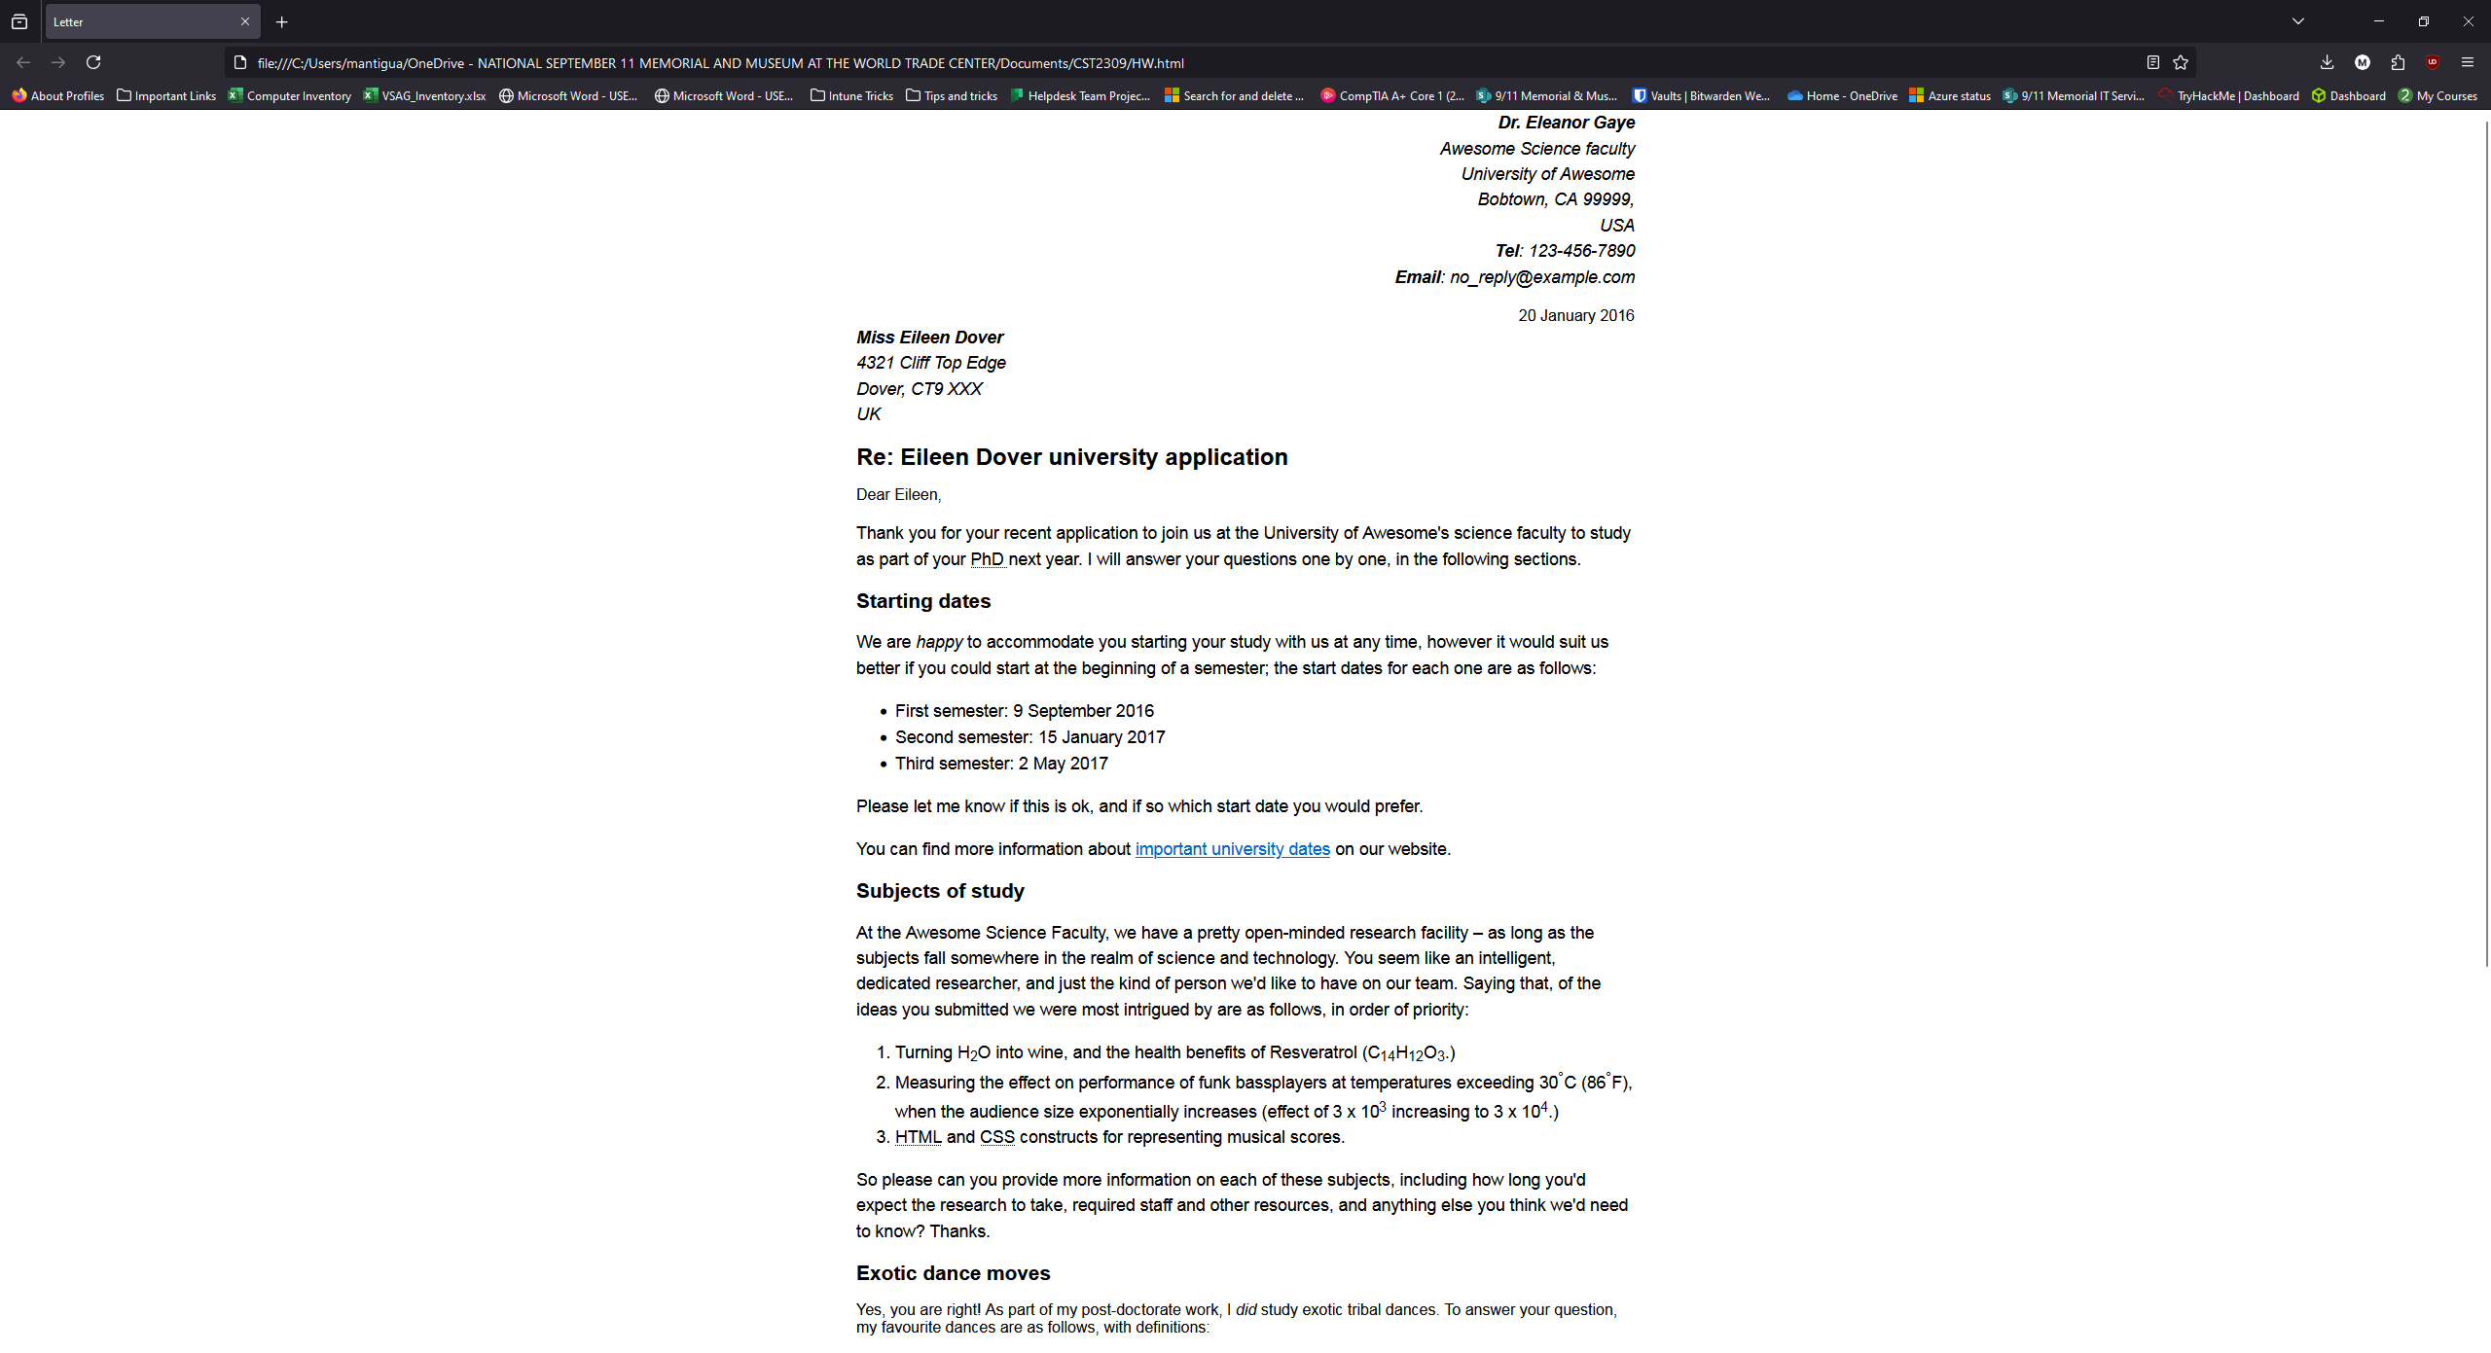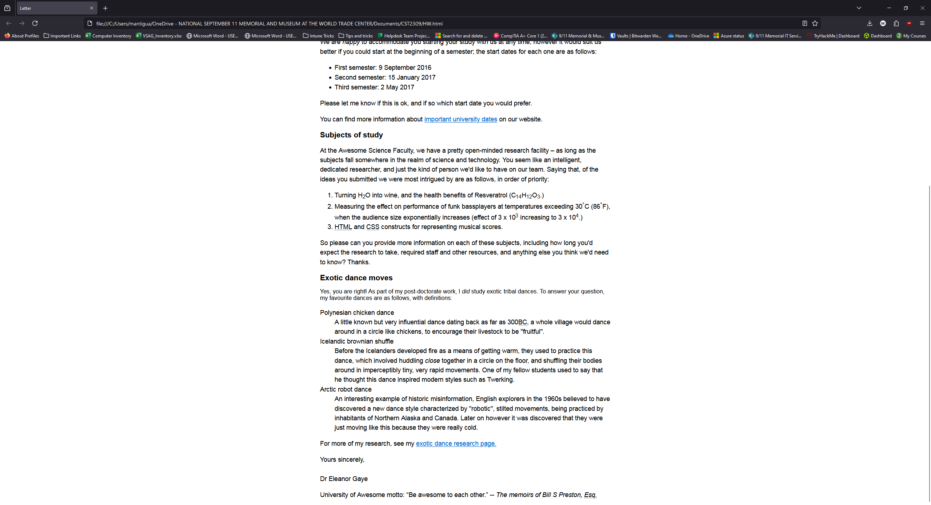

1. Nu HTML Checked results